**Software Specification**

**Document**

**Senior Project – Name TBD**

**09/14/2022**

**V 1.0**

**Emily Sear**

|  |
| --- |
| **Revisions** |

| Version | Primary Author(s) | Description of Version | Date Completed |
| --- | --- | --- | --- |
| 1.0 | Emily Sear | Creation of document & login screen specification | 9/14/2022 |
| 1.1 | Emily Sear | Home screen specification | 10/10/2022 |
| 1.2 | Emily Sear | Daily log & In-depth log specifications | 10/29/2022 |

|  |
| --- |
| **Table of Contents** |

1. Introduction 3

1.1 Purpose

1.2 References

2. Account Relational Database 3

2.1 Naming Conventions

2.2 Database Identification

2.3 Relationship to Other Databases

2.4 Schema Information

3. Login Screen 4

3.1 Description

3.2 User Interface Design

3.3 Specification Table for Login Screen

4. Account Creation Screens 5

4.1 Description

4.2 User Interface Design

4.3 Specification Table for Account Creation

4. External Interface Requirements 7

4.1 User Interfaces 7

4.2 Hardware Interfaces 10

4.4 Software Interfaces 10

5. Non-Functional Requirements 10

1. Introduction

* 1. **Purpose:**

The goal of this project is to solve the problem of having no central place for a person to easily track all of their symptoms digitally. Along with this, this project hopes to help track data of the user and provide an easy format for the user to share this data with medical professionals. This project will not provide any medical diagnostics but rather a platform that allows better communication and informed decisions to be made from the data being shown.

* 1. **References:**

Please refer to the requirements document:  
<https://1drv.ms/w/s!AuuqMspVScWFgak-X_rLrV-1RxukoA?e=5POFBV>

## 2. Account Relational Database

**2.1 Naming Conventions:**

This database will be created with using _ between each word in the name of the variable. For example, a variable for first name would be ‘first_name’. Tables should be named with plural words if there is an option to do so that they do not conflict with any reserved words within the database. Primary keys should be named with the tableName_id to help with debugging and understanding what keys came from where. All variable names should be unambiguous as possible, names should also be self-explanatory of what they represent.

**2.2 Database Identification:**

Database Name: chronically_tracking_account  
Table Names:

users – primary key: user_id

diagnoses – primary key: diganosis_id

medications – primary key: medication_id

* 1. **Relationship to Other Databases:**

This database will interact with the nonrelational database, with the primary key for the user table to be the key for the nonrelational database.

* 1. **Schema Information:** 
     1. **Description**

This database currently consists of one schema, users with three tables. The tables names are personal_details, medications, and diagnoses. personal_details entails the details needed for the user’s account like name, email, and password. medications will include all data related to the medication. Lastly, diagnoses will include the name of the diagnoses that a user might have.

* + 1. **Physical Design & Structure**

users:

## 3. Daily Log Non-Relational Database

**3.1 Naming Conventions:**

This database will be following the same naming conventions that the account relational database follows. Please see above for all naming conventions.

**3.2 Database Identification:**

Database Name: chronically_tracking_daily_logs

* 1. **Relationship to Other Databases:**

This database will interact with the account relational database. This database will get the email from that database and store that with this data to correctly identify what data goes with what user.

* 1. **Structure of NoSQL**
     1. **Description**

This database will consist of json that passes the values that associate with the fields filled out with the daily log forms. This database will have a general structure, but all content will be subject to what the user puts in for that current day.

* + 1. **Physical Design & Structure**

1. {
2. ”log_id” : 0,
3. "email" : "",
4. "overall_scale" : 0,
5. "pain_scale" : 0,
6. "mood_scale" : 0,
7. "fatigue_scale" : 0,
8. "avg_heart_rate" : 124,
9. "on_period" : true,
10. "datetime" : "datetime",
11. "medications" : [
12. {
13. "medication_name" : "",
14. "time_taken" : "5pm" // datetime?,
15. }
16. ],
17. "symptoms" : [
18. {
19. "name_of_symptom" : "",
20. "severeness" : 0,
21. "time_frame" : "5pm - 7pm",
22. "continue_on_with_life" : true,
23. "area_of_body" : "",
24. "notes" : "",
25. "mental_health" : true
26. }
27. ]
28. }

## 4. Login Screen

**4.1 Description**

The login screen will encompass one screen, which the user is brought to when they enter the application, or when they log out of their account. The login screen will allow the user to access all other screens to the application. The user will be brought to the home screen after they log into the application.

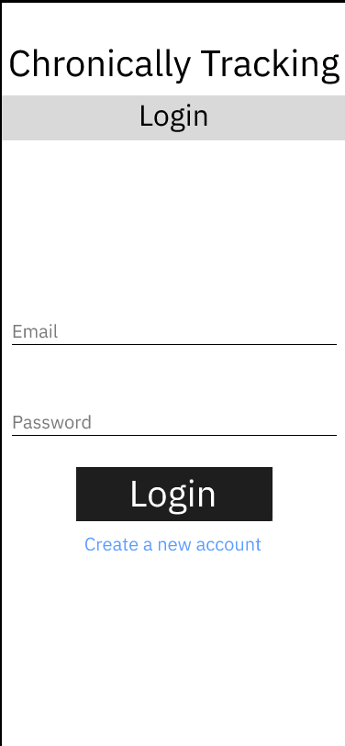

**4.2 User Interface Design**

Login Screen ([link](https://www.figma.com/file/5CEi6DLjqsXbSi7e6HTMOg/Account-Creation-%26-Login-Screens?node-id=4%3A12))

**4.3 Specification Table for Login Screen**

|  |  |  |
| --- | --- | --- |
| **Page Element** | **User Interface / Text (what you see** | **Functionality/ Validation / Behavior (what it does)** |
| **Normal State** |  |  |
| Title | Chronically Tracking (centered) |  |
| Page Banner | Login (centered, banner is greyed out) |  |
| Email input box | Email (in grey) Line underneath ‘Email’ for user to enter their email into | -checks with the MailAddress class (C#) if email is valid |
| Password input box | ‘Password’ (in grey) Line underneath ‘Password’ for user to enter their email into | -password must:  -have at least one lowercase, one uppercase, one number and one character  -at least 8 characters long |
| Login Button | Black button (centered)  Text: ‘Login’ in white | Validates email & password and checks against the database.  If email and/or password is not a match, error states are shown.  If a match is found, user is taken to the homescreen of the application |
| Create a new account text | ‘Create a new account’  In blue, centered | Link to take users to the ‘Account Creation’ flow |
| **Error States** |  |  |
| Email/password not valid | ‘Sorry, we couldn’t find an account with that email and password combination. Please try again.’ red text, centered about the email input box | Shown when email or password does not pass validation.  Goes away once user starts typing on screen |

## 5. Account Creation

**5.1 Description**

The account creation flow will encompass two screens, one for personal details and one for more medical details. The user will get to this flow by clicking the ‘Create a new account’ link on the login screen. If successful, the user will be brought to the homescreen of the application.

**5.2 User Interface Design**

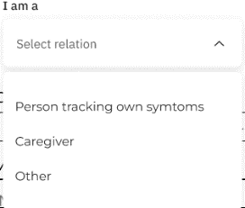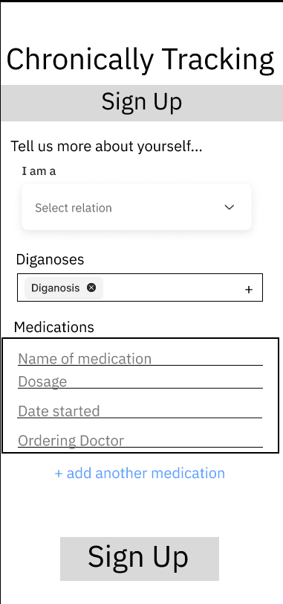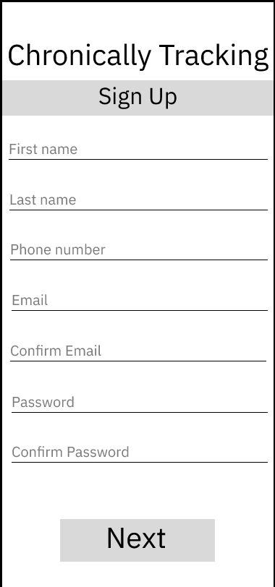Sign Up Screens ([link](https://www.figma.com/proto/5CEi6DLjqsXbSi7e6HTMOg/Account-Creation-%26-Login-Screens?node-id=19%3A112&scaling=min-zoom&page-id=15%3A4))

**5.3 Specification Table for Account Creation**

|  |  |  |
| --- | --- | --- |
| **Page Element** | **User Interface / Text (what you see** | **Functionality/ Validation / Behavior (what it does)** |
| **Personal Details Page** |  |  |
| Title | Chronically Tracking (centered) |  |
| Page Banner | Sign up (centered, banner is greyed out) |  |
| First name input box | ‘First name’ (in grey) Line underneath ‘First name’ for user to enter their name into | Limited to 30 characters |
| Last name input box | ‘Last name’ (in grey) Line underneath ‘Last name’ for user to enter their name into | Limited to 30 characters |
| Email input box | ‘Email’ (in grey) Line underneath ‘Email’ for user to enter their email into | -checks with the MailAddress class (C#) if email is valid  -limited to 50 characters |
| Confirm Email input box | ‘Confirm email’ (in grey) Line underneath ‘Confirm Email’ for user to enter their email into | -checks with the MailAddress class (C#) if email is valid  -limited to 50 characters  -has to match email in the ‘email input box’ |
| Password input box | ‘Password’ (in grey) Line underneath ‘Password’ for user to enter their email into | -password must:  -have at least one lowercase, one uppercase, one number and one character  -at least 8 characters long  -limited to 60 characters |
| Confirm password input box | ‘Confirm password’ (in grey) Line underneath ‘Confirm password’ for user to enter their email into | -password must:  -have at least one lowercase, one uppercase, one number and one character  -at least 8 characters long  -limited to 60 characters  -must match password given in the ‘password input box’ |
| Next Button | Grey button (centered)  Text: ‘Next’ in black | -Makes sure all the fields are filled according to their validation  -takes user to the |
| Create a new account text | ‘Create a new account’  In blue, centered | Link to take users to the ‘Create an Account’ flow |
| **Medical Details** |  |  |
| Title | Chronically Tracking (centered) |  |
| Page Banner | Sign up (centered, banner is greyed out) |  |
| Label text | ‘Tell us more about yourself…’ |  |
| ~~Relation Drop Down~~ | ~~Label: ‘I am a’~~  ~~Options: ‘Person tracking own symptoms’, ‘Person tracking another’s symptoms’, ‘other’~~ |  |
| Label Text | ‘Diagnoses’ |  |
| Search Multi-Input Field | Input Box Field Has a compartment for each diagnoses, includes name and x button. | Allows user to type in diagnosis, which will search the diagnosis database, if the name is not found, a new field will be allowed to be added |
| Label Text | ‘Medications’ |  |
| Medication input card | Box around below inputs labeled with ‘Medication – {name}’ |  |
| Medication – name of medication input text | Text: ‘Name of medication’ in grey Line underneath text | -limited to 45 characters |
| Medication – dosage | Text: ‘Dosage’  Line underneath text | -limited to 30 characters |
| Medication – date started | Text: ‘Date started’ in grey Line underneath text |  |
| Medication – ordering doctoring | Text: ‘Ordering doctor’ in grey  Line underneath text | -limited to 60 characters |
| Add another medication link | Text: ‘+ add another medication’ in blue | Allows user to fill out another medication card |
| Terms and conditions check | Text: ‘I have read and accept the terms and conditions outlined here.’ | Has to be marked in order to create an account |
| Sign Up Button | Text: ‘Sign up’  Grey Button with black text | Makes sure all above information is validated and submits all the information to the various databases |
| **Error States** |  |  |
| Email in use | ‘Sorry, that email already has an account. Please sign into the account with that email or reset the password associated with that account.’ Red notification error | Sign links to the login screen |

## 6. Home Screen

**6.1 Description**

The home screens will be the base of the application. The user will be able to enter these screens by logging into their account. These screens will also be where the user is able to access all of their data including but not limited to the Daily Log flow, the print screen, and a screen that shows them their daily logs.

**6.2 User Interfaces**

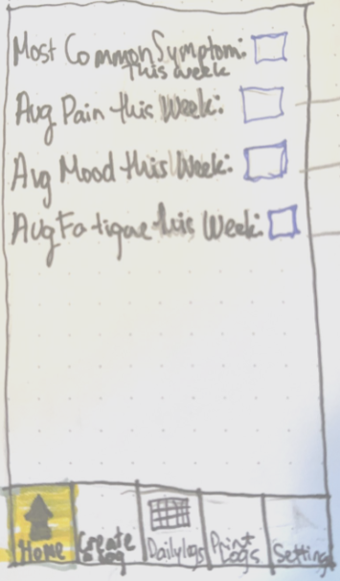 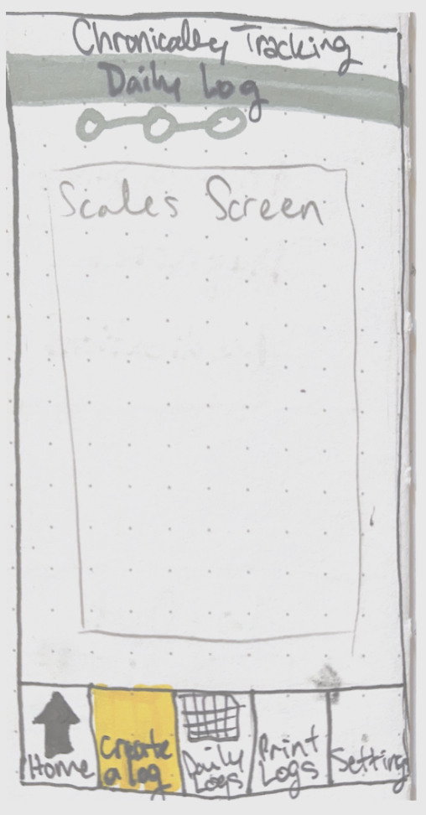 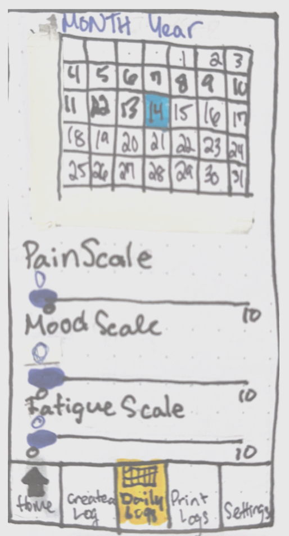 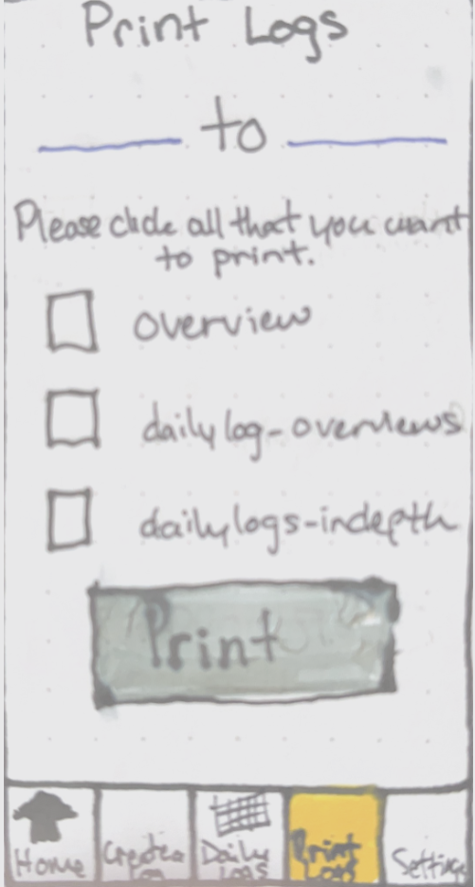

**6.3 Specification Table for Home Screen**

|  |  |  |
| --- | --- | --- |
| **Page Element** | **User Interface / Text (what you see** | **Functionality/ Validation / Behavior (what it does)** |
| **Home page** |  |  |
| Most Common Symptom | ‘Most common symptom this week:’ (Black text)  + most_common_symptom (black text)  Underline underneath most_common_symptom | -Most_common_symptom will be calculated with the highest logged symptom from 7 days ago to today.  -if there is a tie, the symptom with the largest number on the severeness scale will be shown |
| Average Pain | ‘Average amount of pain this week:’ (Black text) +  Average_amount_of_pain (black text)  Underline underneath average_amount_of_pain | -average_amount_of_pain will be calculated from the numbers from the pain scale for the past 7 days |
| Average Mood | ‘Average mood this week:’ (Black text) +  Average_mood (black text)  Underline underneath average_mood | -average_mood will be calculated from the numbers from the mood scale for the past 7 days |
| Average Fatigue | ‘Average amount of fatigue this week:’ (Black text) +  Average_amount_of_fatigue(black text)  Underline underneath average_amount_of_fatigue | -average_amount_of_fatigue will be calculate from the numbers from the fatigue scale for the past 7 seven days |
| Bottom Banner |  |  |
| **Create a log page** |  |  |
| Daily Log Screen |  |  |
| Bottom Banner |  |  |
| **Daily Logs Page** |  |  |
| Calendar Component | Show a calendar object | -date is selected on today’s date  -user is able to click back to the date in which they created their account |
| Pain Scale | Label: ‘Pain Scale’  Slider underneath labeled 0 – 10 | -Slider is marked where the user selected their amount of pain for the day selected by the calendar object |
| Mood Scale | Label: ‘Mood Scale’  Slider underneath labeled 0 - 10 | -Slider is marked where the user selected their mood for the day selected by the calendar object |
| Fatigue Scale | Label: ‘Fatigue Scale’  Slider underneath labeled 0 – 10 | -Slider is marked where the user selected their amount of fatigue for the day selected by the calendar object |
| Bottom Banner |  |  |
| **Print Logs Page** |  |  |
| Title | ‘Print Log’ (black text) |  |
| Dates | Date_start + ‘to’ + date_finish (black text) | -date_start is a chosen date to be in the pdf  -date_end is a chosen date to be in the pdf  -if either date_start or date_end is chosen, then a calendar pops up with the current date on it  -date_start cannot be greater than date_end  -date_start & date_end cannot be greater than the current date  -does not show if no logs are filled out |
| Print Label | ‘Check all below that you want to include in your print’ (black text) | -does not show if no logs are filled out |
| Overview | Checkbox + ‘Overview’ | Check in checkbox when clicked, empty when not  -does not show if no logs are filled out |
| Daily Log | Checkbox + ‘Daily logs – overviews’ | Check in checkbox when clicked, empty when not  -does not show if no overview logs are filled out |
| Daily log – indepth | Checkbox + ‘Daily logs – indepth’ | Check in checkbox when clicked, empty when not  -does not show if no indepth logs are filled out |
| Error Message | ‘You have not filled out any daily logs yet, please fill out a daily log to print out your data.’ (red text) | -Only shows if there are no log filled out |
| Bottom Banner |  |  |
| **Settings Page** |  |  |
| Account | ‘Account’ (centered, black text) | -takes user to screen similar to sign up  TODO: spec this out |
| Privacy & Safety | ‘Privacy & Safety’ (centered, black text) | -takes user to privacy & terms and conditions documents |
| Diagnoses | ‘Diagnoses’ (centered, black text) | -takes user to screen similar to diagnoses sign up page to add or remove diagnoses |
| Medications | ‘Medications’ (centered, black text) | -takes user to screen similar to medications sign up page to add or remove medications |
| Log Out | ‘Log out’ (centered, black text) | -logs user out of their account and takes them to the login screen |
| Bottom Banner |  |  |
| **Bottom Banner** |  |  |
| Home | Home icon + ‘Home’ (centered, black text) | -takes user to Home Page  -Highlighted when user is on the home page |
| Create a log | ‘Create a log’ (centered, black text) | -takes user to Create a Log Page  -Highlighted when user is on the create a log page |
| Daily Logs | Excel table icon + ‘Daily Logs’ (centered, black text) | -takes user to Daily Logs page  -Highlighted when user is on the daily logs page |
| Print logs | ‘Print Logs’ (centered, black text) | -takes user to Print Logs page  -Highlighted when user is on the print logs page |
| Settings | Settings Gear icon + ‘Settings’ (centered, black text) | -takes user to settings page  -Highlighted when user is on the settings page |

## 7. Daily Log – Overview

**7.1 Description**

The user will get to the daily log section by the “New log” button on the bottom bar of the application. This log will allow the user to track their symptoms. This log will also allow the user to get to the “daily log – indepth” section which would allow them to tell more about their symptoms. This flow will finish with the user submitting their information which will then be stored in daily log nonrelational database.

**7.2 User Interfaces**

Daily Log – Overview ([link](https://www.figma.com/proto/W01BBHkhgpsqEAIJyjye8f/Daily-Log?node-id=13%3A15&scaling=scale-down&page-id=0%3A1))

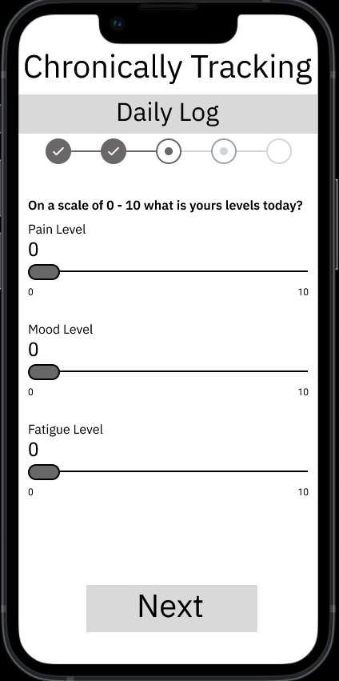 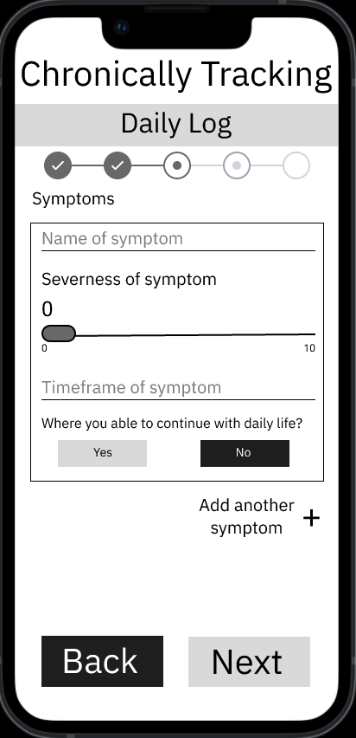 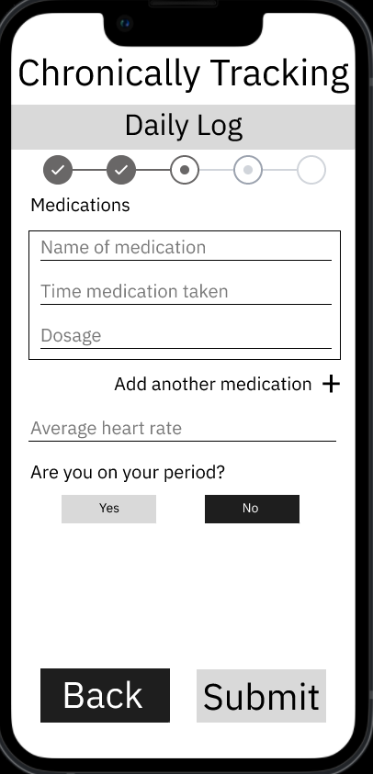

Daily Log – In-depth ([link](https://www.figma.com/proto/W01BBHkhgpsqEAIJyjye8f/Daily-Log?node-id=31%3A247&scaling=min-zoom&page-id=31%3A14))

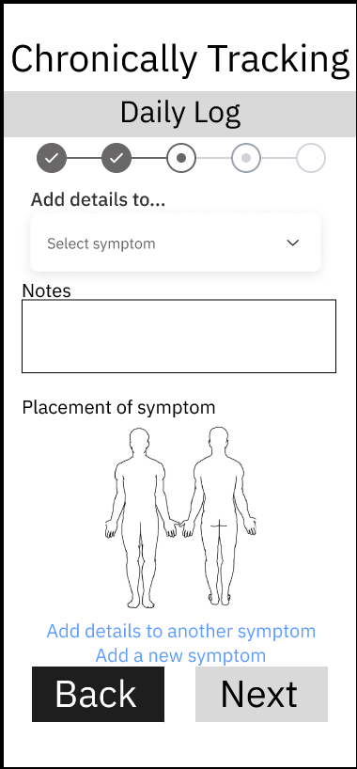 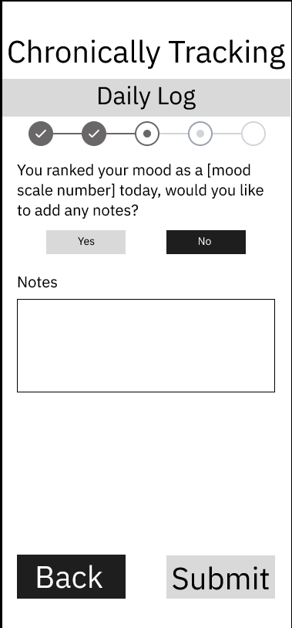

**7.3 Specification Table for Daily Log - Overview**

|  |  |  |
| --- | --- | --- |
| **Page Element** | **User Interface / Text (what you see** | **Functionality/ Validation / Behavior (what it does)** |
| **Daily Log Levels Page** |  |  |
| Title | Chronically Tracking (centered) |  |
| Title Banner | Daily Log – grey banner |  |
| Progress Tracker | No circles filled in – 4 circles for progress tracker |  |
| Top Question | ‘On a scale of 0 – 10, 0 being the best, what are your levels today?’  -black text |  |
| Pain Level | ‘Pain Level’  Slider underneath labeled 0 - 10 | -sets “pain_scale” field in the daily log database |
| Mood Level | ‘Mood Level’  Slider underneath labeled 0 - 10 | -sets “mood_scale” field in the daily log database |
| Fatigue Level | ‘Fatigue Level’  Slider underneath labeled 0 – 10 | -sets “fatigue_scale” field in the daily log database |
| Next Button | ‘Next’  Black text, button color is light grey | -takes user to the daily log-symptoms page |
| Bottom Banner |  |  |
| **Daily Log Symptoms Page** |  |  |
| Title | Chronically Tracking (centered) |  |
| Title Banner | Daily Log – grey banner |  |
| Progress Tracker | 1st circle filled in – 4 circles for progress tracker |  |
| Symptoms Label | ‘Symptoms’  Black Text |  |
| Symptom input card | Box around below inputs |  |
| Name of Symptom Input | ‘Name of symptom’ – light grey, placeholder  Underline underneath | -required  -sets name_of_symptom field |
| Severeness of Symptom | ‘Severeness of Symptom’ – black text  Slider underneath labeled from 0 -10 | -sets severeness field |
| Timeframe of Symptom | ‘Timeframe of symptom’ -light grey, placeholder  Underline underneath | -sets time_frame field |
| Daily Life | ‘Were you able to continue with daily life?’  -‘Yes’ – box black text, grey box  -‘No’ – white text, black box | -sets continue_on_with_life field |
| Placement | ‘Placement of Symptom’  -Grey text, placeholder  -Underlined with black | -Input box  -sets area_of_body field |
| Notes Label | ‘Notes’  -black text |  |
| Notes Box | Black box | -sets notes field on the symptoms object |
| Mental Health Label | ‘Is this symptom related to mental health?’  -black text |  |
| Mental Health choices | ‘Yes’ – Grey box black text  ‘No’ – black box, white text | -sets the mental health field |
| Symptom input card ends |  |  |
| Add another symptom | ‘Add another symptom +’  Black text | -button to add another symptom to the list of symptoms  -clears out the card |
| Back Button | ‘Back’  -black box, white text | -takes user to the daily log - levels page |
| Next Button | ‘Next’  -Grey button, black text | -takes user to the daily log- medications page |
| Bottom Banner |  |  |
| **Daily Log Medications Page** |  |  |
| Title | Chronically Tracking (centered) |  |
| Title Banner | Daily Log – grey banner |  |
| Progress Tracker | 2nd circle filled in – 4 circles for progress tracker |  |
| Medications input card | Box around the below fields |  |
| Name of medication input | ‘Name of medication’  -grey text, placeholder  -black underline | -sets the medication_name field |
| Time input | ‘Time medication taken’  -grey text, placeholder  -black underline | -sets the time_taken field |
| Dosage input | ‘Dosage’  -grey text, placeholder  -black underline | -sets the dosage field |
| Medications input card end |  |  |
| Add another | ‘Add another medication +’  -black text  -button | -clears out the medications input card |
| Back Button | ‘Back’  -white text  -back box | -takes user to daily log- symptoms page |
| Next Button | ‘Next’  -Black text  -grey box | -takes user to daily log- other page |
| Bottom Banner |  |  |
| **Daily Logs Other Page** |  |  |
| Title | Chronically Tracking (centered) |  |
| Title Banner | Daily Log – grey banner |  |
| Progress Tracker | 3rd circle filled in – 4 circles for progress tracker |  |
| Heart Rate Input | ‘Average heart rate’  -grey text, placeholder  -underline underneath texts | -sets avg_heart_rate field |
| Period Label | ‘Are you on your period?’ |  |
| Period Input | -Grey Button, Black Text 🡪 ‘Yes’  -Black Button, White Text 🡪 ‘No’ | -sets on_period field |
| Back Button | ‘Back’  Black Button, White Text | -takes user to Daily logs medications |
| Submit Button | ‘Submit’  Grey Button, Black Text | - data is submitted to the database & user is taken to the homescreen view |
| Bottom Banner |  |  |

## 7. External Interface Requirements

6.1 User Interfaces

Login Screen ([link](https://www.figma.com/file/5CEi6DLjqsXbSi7e6HTMOg/Account-Creation-%26-Login-Screens?node-id=4%3A12))  


Sign Up Screens ([link](https://www.figma.com/proto/5CEi6DLjqsXbSi7e6HTMOg/Account-Creation-%26-Login-Screens?node-id=19%3A112&scaling=min-zoom&page-id=15%3A4))

 

Daily Log – Overview ([link](https://www.figma.com/proto/W01BBHkhgpsqEAIJyjye8f/Daily-Log?node-id=13%3A15&scaling=scale-down&page-id=0%3A1))

  

Daily Log – In-depth ([link](https://www.figma.com/proto/W01BBHkhgpsqEAIJyjye8f/Daily-Log?node-id=31%3A247&scaling=min-zoom&page-id=31%3A14))

 

Home Screen

   

6.2 Hardware Interfaces

This application will be able to run on all currently supported Android and IOS devices.

6.3 Software Interfaces

The backend software will be written with C++ in visual studio. The android frontend software will be built with visual studio. The relational database will be built with SQL and communicated with such. The nonrelational database will be built with json and communicated with such.